


West Coast Collaborative
Specialist Mathematics Units 3 & 4
Investigation 1 2018
Wheel of Steel Investigation

Take Home Task: Due: Tuesday 1st May.

Validation Test: Thursday 3rd May. You will be permitted to bring in your take-home component and calculator.

Introduction
The Wheel of Steel is a vast piece of revolving circus apparatus with revolving wheels at either end. Highly trained artists perform both inside and outside the wheel whilst maintaining balance and grace as the wheel turns.
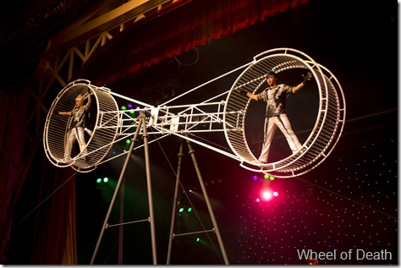

The Wheel of Steel can be modelled by the diagram below:
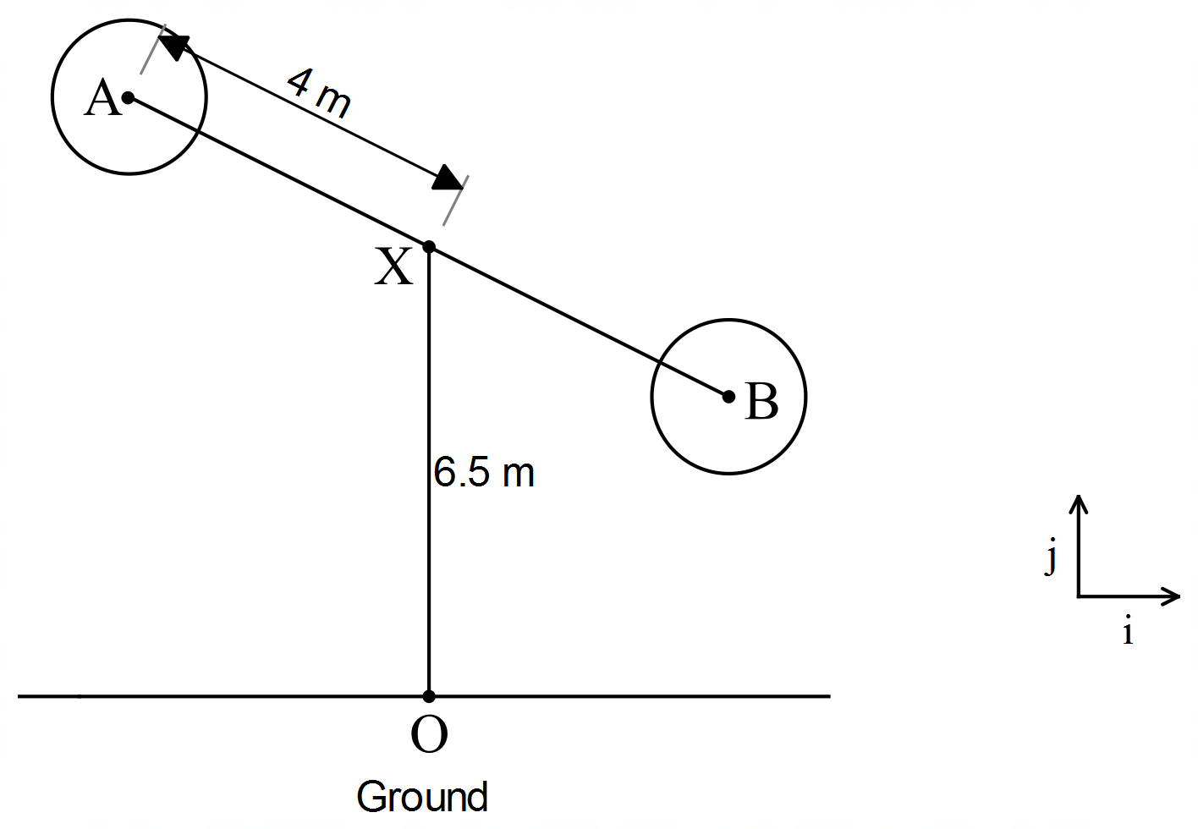
The central rod AB revolves about X. Mini wheels are rotating about A and B.
The vector equation describing the motion of A t minutes after the Wheel of Steel starts is
r (t) = 4 sin (2π t) i + (–4cos (2π t) + 6.5) j , where all distances are measured in metres.

Questions to answer
- Where is A when the ride starts? Find the position vector of A for t = 0..25, 0.5, 0.75
In which direction is A rotating and how long does it take for A to complete one
revolution?

- In the equation r (t) = 4 sin (2π t) i + (–4cos (2π t) + 6.5) j, explain why:
- the frequency is 2π
- the amplitude is 4
- the coefficient of the the j component has “+ 6.5”
- the i component is defined in terms of sine
- the j component is defined in terms of –cosine

- Find vector equations for the velocity and acceleration of the point A at time t.
Find the speed of A at time t.

- Find the Cartesian equation of the path of A and find the distance OA when t = 0.25.

- State the position vector of point B at time t minutes.

- State the position vector for the motion of A if when t = 0 the position vector of A is
4i + 6.5j and AB is revolving about X in a clockwise direction at the same speed in c.

